“Inspiration to Aspire”
“All shall be well”
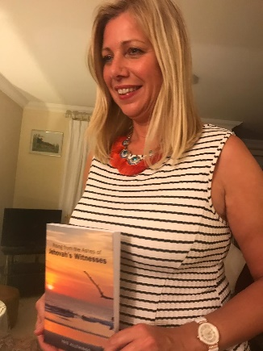
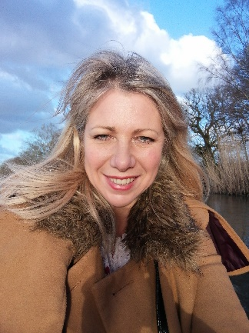
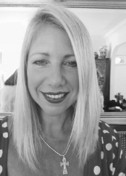
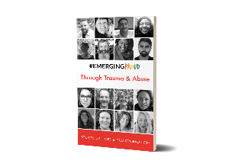
Julian Wise – Author, Mentor & Reiki Healer
What do you need and why?
“People use mentors to create visions, fire their inspiration, fulfil aspirations”
Would you like to shift your understanding of who you are and see how the world around you can work for you, not against you, by changing the story we are conditioned with? I have been through this journey myself by escaping an oppressive fundamentalist religion twenty-five years ago and have learnt how to fly as a free spirit. During this metamorphosis I became an author, having written the book “Rising from the Ashes of Jehovah’s Witnesses” under author alias Isisi Allthings. You can find out more about my book here: https://isisallthings369.wixsite.com/realnews or buy it here: http://www.lulu.com/spotlight/Freespirit369
My story is also included in the pocket book by #EmergingProud Press “Through Trauma and Abuse - Stories of Hope & Transformation.” You can buy this book here: https://emergingproud.com/kindaproud/buy-the-books/
Together, we will support your unique truth to emerge, to allow your core talents to surface, inspiring positive results. This can also include Reiki healing if desired, which releases the energies of change and upliftment.
What is my aim when I work with you?
Wisdom coaching is different from aspiring in a material way i.e. goal setting, targets, acquiring material things, advancing in your career. Rather, wise mentoring helps you to return to your true inner peace. You will learn how to let go of unrealistic expectations and self-judgement, in order to move away from a life of suffering and stress. When this is understood and practiced it keeps you in the present moment of bliss and flow. Package details at bottom.
This is where exciting things can happen and your true needs are met
We will learn that our internal self is where the magic can start to bubble forth. Imagine waking up each day and knowing that something wonderful is going to happen, no matter how small it may seem. No longer caught in the entanglement of mind and thoughts that hurt you, can lead you to true freedom.
It really works and is a lot of fun!
Change your perception, change your life!

To work with me see below…

How it works

​

3 free exploratory sessions

1 hour each over 5 weeks

​

Followed by 2 months

of 2 sessions each month

£150 a month

Total 3 months = £300

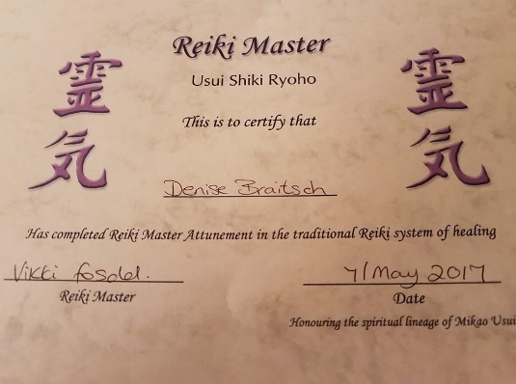
Reiki Masters certification (in my legal name, Denise Braitsch)

To book your initial 3 free sessions, email: Inspiring2Aspire@gmail.com
You can message me on my website chat: https://isisallthings369.wixsite.com/coaching

