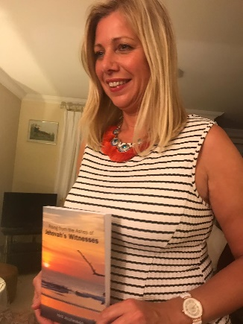
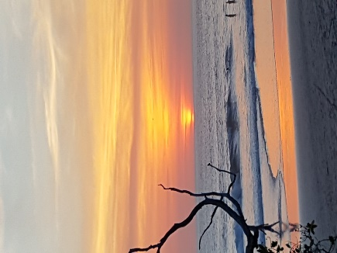
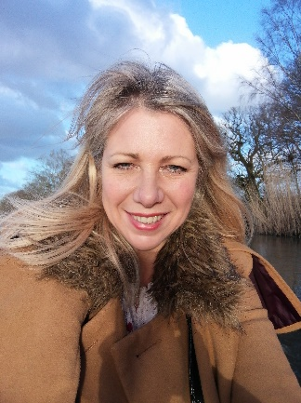
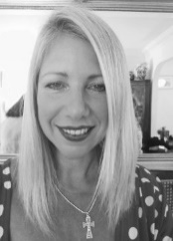
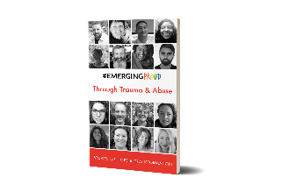
Isisi Allthings – Mentor, Reiki Healer, Author
“All is Well”

What is my aim when I work with you?
My coaching is not about goal setting or achieving targets per se. It's about gently supporting yourself
In order that you can give yourself comfort and self-care during these challenging times

What do you need right now?
What do you need during the COVID19 self-isolation or enforced quarantine?
How is it affecting you and what kind of support do you feel you want?
Many are experiencing anxiety, fear and loneliness
​We can look at a toolkit for you in the following areas:
- Nutrition and practical support
- Mental health support
- Emotional health support
- Spiritual support*
*This can also include Reiki healing if desired, which calms and releases energies of change and upliftment

Change your perception, change your life!

To work with me see free offer below…

How it works:

COVID19 OFFER of free* exploratory sessions

(1 hour sessions normally £50)

*I would like to use your free sessions as a case study with all names redacted

To book your initial free session, email me : isisallthings369@gmail.com
Or you can message me on my website chat: https://isisallthings369.wixsite.com/coaching

Reiki Masters certificate available on request

Recommendation/case study:

Sonia Hull
“I feel very blessed to have met this wonderful woman four years ago and we clicked straight away. I was going through a very difficult time in my life and this wonderful soul proved to not only be a guiding light to me spiritually, but understood me in a deeply emotional and mental way too. Isisi has calmly guided me through many aspects of my life with intelligence and a wonderful serenity. I cannot recommend her highly enough and would be lost without her” – Sonia Hull, March 2020

Isisi Allthings – Case Study summary
“Sonia has grown incredibly in many ways over the years, she came from an abusive background where she was given no practical parental role model, let-alone the emotional support that every child needs to flourish. Our friendship and subsequent mentoring acted as a catalyst for Sonia to safely learn the skills of self-parenting, as I have had to do in many areas. None of us have had an ideal childhood, but Sonia undertook a massive journey of self-acceptance and forgiveness around the things she endured in the past and has now let go.

I have grown a deep respect for the many changes she has made with my support and this took a lot of courage and self-love on her part. She has transformed from someone with deep depression and many other complex personal issues, into someone who is now stepping into her own power, with self-confidence about where she wants to take her life. She has turned her self-destructive tendencies into positives and has now embarked on a dream she has held dear for many years, to be become an author. She is planning further steps to become a speaker and mentor, in order to help parents and children subjected to PAS (Parental Alienation Syndrome), who have experienced the injustices that she has had to endure. She is determined that people be given the right advice at the right time to support them to not just survive but thrive through family break-up and divorce”. – Isisi Allthings, April 2020

See below for bio and information about my background and the changes I have made to become a free spirit….
Isisi Allthings bio
Would you like to shift your understanding of who you are and see how the world around you can work for you, not against you, by changing the story we are conditioned with? I have been through this journey myself by escaping an oppressive fundamentalist religion twenty-five years ago and have learnt how to fly as a free spirit. During this metamorphosis I left full-time office employment in 2018, travelled to exotic locations for inspiration and became an author in 2019, having written the book “Rising from the Ashes of Jehovah’s Witnesses” under author alias Isisi Allthings. I had psychotherapy and have also spent many years in self-development including becoming a Reiki Master.
I can help you with change as I take you through the steps I had to take over the years, to see the bigger picture and transform my life.
“Are you a slave to religion or your pay packet? Why are you here? If you would like to explore these questions, follow me on my journey out of one of the Western world's most coercive Christian fundamentalist religions, Jehovah's Witnesses.
In my autobiography I explain how to recognise a cult and to protect your family from the life damaging effects. I offer hard-won insights through my personal story and true life experiences as a woman who was a full-time minister, wife and mother within Jehovah's Witnesses.
I detail the stepping-stones that led to my big escape to becoming a free spirit...this is a real opportunity for all who have a yearning to be free.” Buy my book here: http://www.lulu.com/spotlight/Freespirit369
You can find out more about my book and see some interviews on my website: https://isisallthings369.wixsite.com/realnews
A brief synopsis of my story is also included in the pocket book by #EmergingProud Press organized by Katie Mottram called “Through Trauma and Abuse - Stories of Hope & Transformation.” Buy this book here: https://emergingproud.com/kindaproud/buy-the-books/
Together, we will support your unique truth to emerge, to allow your core talents to surface, inspiring positive results. This can also include Reiki healing if desired, which releases the energies of change and upliftment.
What is my aim when I work with you?
Wisdom coaching is different from aspiring in a material way i.e. goal setting, targets, acquiring material things, advancing in your career. Rather, wise mentoring helps you to return to your true inner peace. You will learn how to let go of unrealistic expectations and self-judgement, in order to move away from a life of suffering and stress. When this is understood and practiced it keeps you in the present moment of bliss and flow.
This is where exciting things can happen and your true needs are met
We will learn that our internal self is where the magic can start to bubble forth. Imagine waking up each day and knowing that something wonderful is going to happen, no matter how small it may seem. No longer caught in the entanglement of mind and thoughts that hurt you, can lead you to true freedom.
It really works and is a lot of fun!

Change your perception, change your life!

